# CHAPTER 1

### INTRODUCTION

The plantation drive in Gudemaranahalli represents a significant step towards enhancing the local environment and promoting sustainable practices within the community. This initiative, aimed at improving green cover and fostering ecological balance, involved planting tree saplings in a carefully planned and executed manner. By incorporating compost, coconut dry shells, and manure, the drive ensured that the saplings had a nutritious and supportive foundation for healthy growth. This approach not only helps in the immediate greening of the area but also sets the stage for long-term environmental benefits, such as improved air quality, increased biodiversity, and better soil health.

Furthermore, the initiative served as a platform to educate the community about the importance of sustainable practices and the role of teamwork in environmental conservation. Participants were divided into specific teams, each with distinct tasks such as planting, distributing manure, and documenting the event. This division of labor not only ensured efficiency but also provided a hands-on learning experience for everyone involved. The collaboration among participants highlighted the collective effort required to address environmental challenges and emphasized the power of community action. By raising awareness and fostering a sense of responsibility towards the environment, the plantation drive in Gudemaranahalli has not only contributed to immediate ecological improvements but has also laid the groundwork for continued community engagement in sustainable practices.

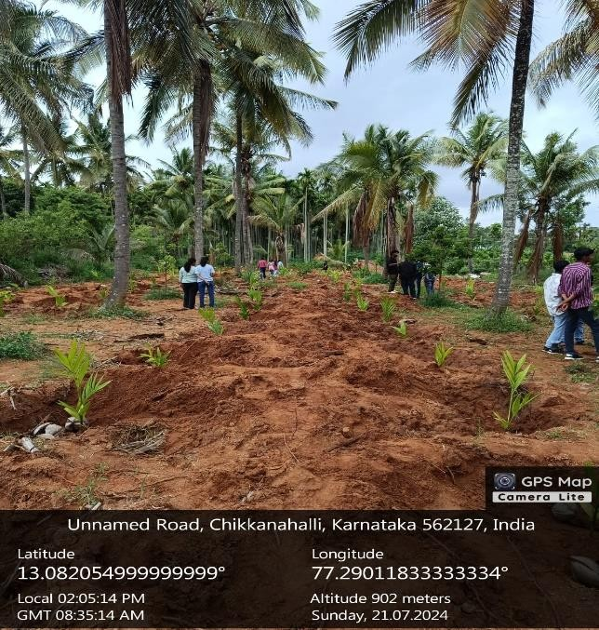

# CHAPTER 2

### OBJECTIVE

The primary objective of the plantation drive in Gudemaranahalli was to enhance the local environment by increasing the green cover and promoting sustainable agricultural practices. By planting tree saplings and incorporating organic materials such as compost, coconut dry shells, and manure, the initiative aimed to improve soil health and support the growth of new trees. This effort was intended to not only contribute to local ecological balance but also to foster long-term environmental sustainability. By increasing green spaces, the drive sought to address issues related to soil erosion, improve air quality, and create a more hospitable habitat for local flora and fauna.

Another key objective was to engage and educate the community about the importance of environmental conservation and sustainable practices. The plantation drive provided a practical platform for residents to learn about and participate in ecological efforts. Through hands-on involvement in planting and caring for the saplings, participants gained insights into the benefits of green cover and the role of sustainable practices in agriculture. By dividing participants into specialized teams, including those responsible for planting, distributing manure, and documenting the event, the initiative aimed to highlight the significance of teamwork and collective action in achieving environmental goals.

Furthermore, the drive sought to enhance community involvement and foster a sense of collective responsibility towards environmental stewardship. By organizing the event and actively involving local residents in every stage of the process, the initiative aimed to strengthen community ties and encourage a proactive approach to local environmental issues. The successful execution of the plantation drive was intended to serve as a model for future community-driven environmental projects, demonstrating the impact of organized efforts and collaborative engagement in promoting a healthier and more sustainable environment for future generations.

# CHAPTER 3

### ABOUT THE PLACE

Gudemaranahalli is a village located in the Chikkaballapur district of Karnataka, India. It is known for its rural setting and agricultural activities. The region is part of the larger Chikkaballapur taluk and is surrounded by scenic countryside typical of the Karnataka region.

The primary crops cultivated in the region include paddy, ragi, maize, and various vegetables, with farming and related trades serving as significant sources of livelihood for the community. The economic activities are deeply rooted in the agricultural cycle, reflecting the traditional practices and economic patterns of the area. This agricultural focus not only sustains the local economy but also shapes the village's daily life and community interactions.

Culturally, Gudemaranahalli is influenced by the rich traditions and practices of Kannada culture. Festivals such as Ugadi and Deepavali, along with local fairs, are celebrated with great enthusiasm, reflecting the vibrant cultural heritage of the region. The infrastructure in Gudemaranahalli, including roads, schools, and healthcare facilities, varies in development compared to urban areas, often reflecting the typical challenges faced by rural communities. Surrounded by rolling hills, farmlands, and the serene South Indian countryside, the village offers a tranquil environment. Connectivity to nearby towns and cities via road networks facilitates the transportation of agricultural produce and access to essential services, linking the village to broader economic and social opportunities.

# CHAPTER 4

### CONDUCTION OF THE ACTIVITY

The plantation drive was conducted in several well-organized phases to ensure a systematic and effective approach:

1. **Preparation Phase**:
   * **Site Selection and Pit Digging**: The first step involved selecting suitable sites for planting the saplings and digging pits to the required depth. This phase was crucial to ensure the saplings had ample space to grow.
   * **Material Transportation**: Essential materials such as compost, coconut dry shells, and manure were transported to the plantation sites. This logistical effort was vital to ensure all necessary resources were available on-site.
2. **Team Segregation and Task Allocation**:
   * **Team Formation**: Teams of 20 people were formed, with each team assigned a specific task to streamline the activities.
   * **Plantation Team**: This team was responsible for planting the saplings in the prepared pits, ensuring they were placed at the correct depth and with adequate spacing.
   * **Manure Distribution Team**: Tasked with distributing compost, coconut dry shells, and manure around the planted saplings to enhance soil fertility and provide essential nutrients.
   * **Mulching Team**: This team carried out mulching around the saplings to conserve soil moisture, reduce weed growth, and improve soil health.
   * **Media Team**: Responsible for documenting the plantation drive, taking photographs, and recording videos to capture the event and create awareness through various media channels.
3. **Implementation Phase**:
   * **Planting and Mulching**: The plantation and mulching teams worked in coordination to ensure each sapling was planted correctly and provided with necessary protective measures.
   * **Material Application**: The manure distribution team systematically applied compost, coconut dry shells, and manure to the planted saplings, ensuring each one received adequate nutrients.
   * **Supervision and Coordination**: Team leaders supervised the activities, ensuring tasks were completed efficiently and any issues were promptly addressed.

#### CHALLENGES FACED

Despite the well-organized approach, several challenges were encountered during the plantation drive:

1. **Logistical Challenges**:
   * **Material Transportation**: Transporting materials to the plantation site posed logistical challenges, particularly in ensuring timely delivery and managing the volume of materials required.
   * **Equipment Availability**: Ensuring sufficient tools and equipment for all participants was a challenge, requiring careful planning and resource management.
2. **Weather Conditions**:
   * **Adverse Weather**: Unpredictable weather conditions, such as sudden rain or extreme heat, posed challenges to the plantation activities, requiring adjustments to the schedule and additional protective measures for the saplings.
3. **Team Coordination**:
   * **Task Management**: Coordinating the activities of different teams and ensuring seamless collaboration was challenging, particularly in managing the workflow and avoiding overlaps or delays.



### CONCLUSION

The plantation drive in Gudemaranahalli was a commendable effort that significantly contributed to enhancing the local environment and promoting sustainable practices. Despite encountering various challenges, the collaborative efforts of the participants led to the successful planting of tree saplings, supported by a thoughtful combination of compost, coconut dry shells, and manure. This well- organized approach, including careful team segregation and task allocation, ensured that the process was both efficient and effective. Each team played a crucial role in the initiative, from planting the saplings to distributing essential nutrients and documenting the event. Their combined efforts highlighted the power of community involvement in environmental conservation and underscored the importance of strategic planning in achieving ecological goals.

Beyond its immediate environmental impact, the plantation drive also served as a valuable educational experience for the participants and the wider community. It demonstrated the significance of teamwork, planning, and sustainable practices in addressing environmental challenges. By engaging the community in hands-on activities and fostering a sense of collective responsibility, the initiative has laid the foundation for continued environmental stewardship. Moving forward, maintaining ongoing efforts and encouraging further community engagement will be crucial to ensuring the long-term success and growth of the planted saplings. This commitment will contribute to a greener and healthier environment, benefiting both current and future generations.